A Novel Blockchain Topology for WSNs Based on IOTA Tangle

Fishing Net Topology

https://github.com/Hongwei00/FishingNetTopology

Hongwei Zhang

B00780843

Winter 2022

Week 1 (January 10, 2022)

* Identify the research problem and new idea
  + Modify/simplify IOTA to make it suitable for WSN.
* WSN
  + Sensors.
  + Monitor and record the physical condition of the environment.
  + Collect data.
* IoT
  + Physical devices, vehicles, home appliances and other items that embed electronics, software, sensors, etc.
  + Connect and exchange data with each other.
  + “IoT is a more complex WSN.”
  + IOTA is for IoT, but not exactly for WSN.
* Customize the block structure based on different WSN topologies.

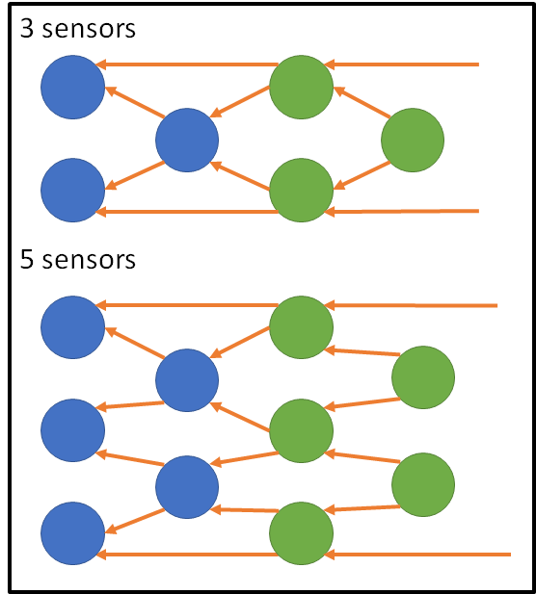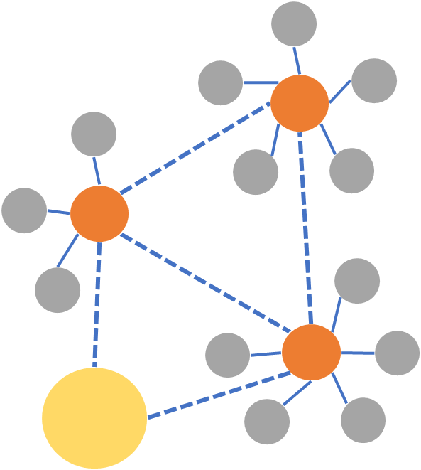

* Implementation
  + Simulate WSN, NS-3.
  + Write programs to simulate blockchain, IOTA, and my new structure.
  + Test the performance…

Week 2 (January 17, 2022)

* Current Plans
  + Research the Tangle Simulator, rewrite the Tangle Simulator, add performance tests.
  + Write a simulator for the new structure based on the Tangle simulator, add performance tests.
  + Compare the simulation test results of the two structures.
  + Build WSN with ns-3, try to simulate the new structure.
* Tangle Simulator: <https://github.com/minh-nghia/TangleSimulator>

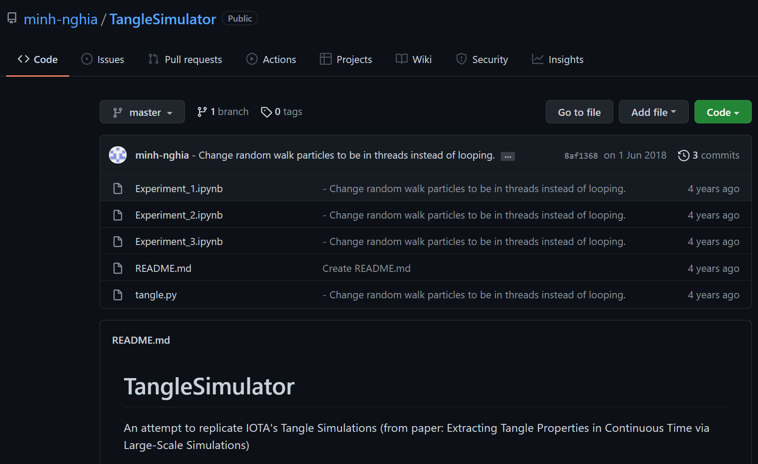

* ns-3 Tutorial: <https://www.nsnam.org/docs/release/3.35/tutorial/singlehtml/index.html>
* ns-3 Manual: <https://www.nsnam.org/docs/release/3.35/manual/singlehtml/index.html>

Week 3 (January 24, 2022)

Existing simulation methods

* [“Characterizing IOTA Tangle with Empirical Data”](https://ieeexplore.ieee.org/abstract/document/9322220)
  + Tangle Size
    - Shortest and longest paths of every tangle.
    - Calculated the ratio of the two paths.
  + Site In-degree
    - K-mean
  + Site Cumulative Weight, CW
    - K-mean
  + Edge Weight, EW
    - Absolute difference of its two sites' respective CW values.
    - This value implies the location of a site to attach to.
* [“Extracting Tangle Properties in Continuous Time via Large-Scale Simulations”](https://assets.ctfassets.net/r1dr6vzfxhev/4T4IAlxk9ym0eWco0UoQIQ/90094e746745b89253eb3636b4ad1597/Extracting_Tangle_Properties_in_Continuous_Time_via_Large_Scale_Simulations_V2.pdf)
  + Cumulative weight is the sum of the own weight of the transaction and the own weights of all transactions that directly or indirectly approve this transaction.
  + Two tips selection mechanism:
    - URTS (uniform random tip selection) algorithm - tips are chosen from the list of available tips randomly (uniform distribution).
    - MCMC (Markov Chain Monte Carlo) algorithm - random walk of particles towards the tips. Particles are released in the tangle, the first k particles at distinct tips determine which transactions are approved.
  + The flow rate of transactions, λ
  + Number of tips
  + The empirical probability density function of the number of tips
  + The average number of tips divided by λ for two tip selection methods
  + The average number of tips divided by flow rate of transactions λ
  + Tangle Visualizations
    - λ
    - h
    - units of time
    - using MCMC with α

Visualization:

* Rate of 10, size of 100

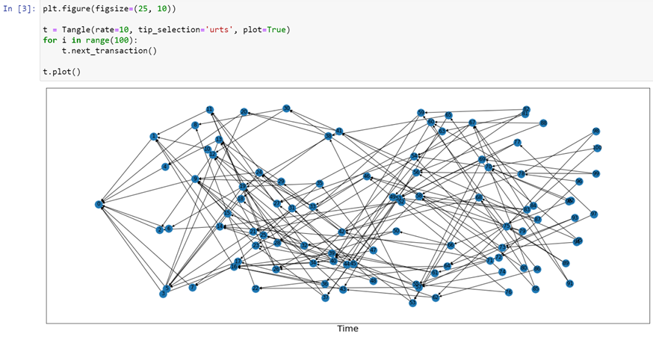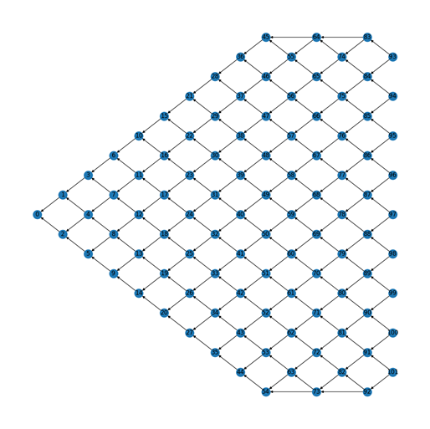

* Rate of 10, size of 1000

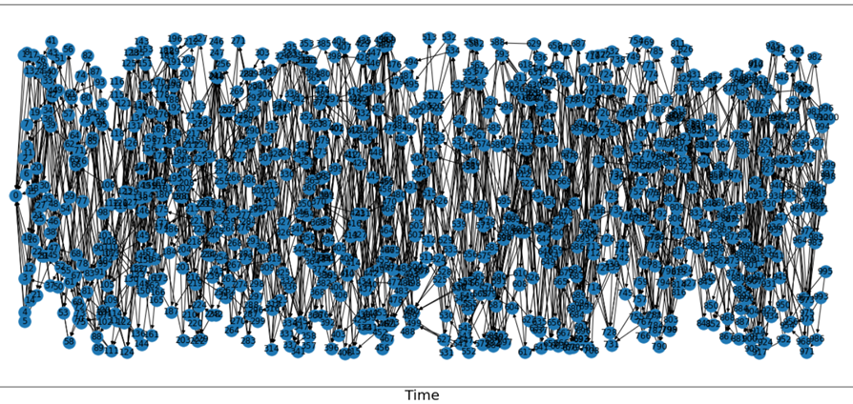

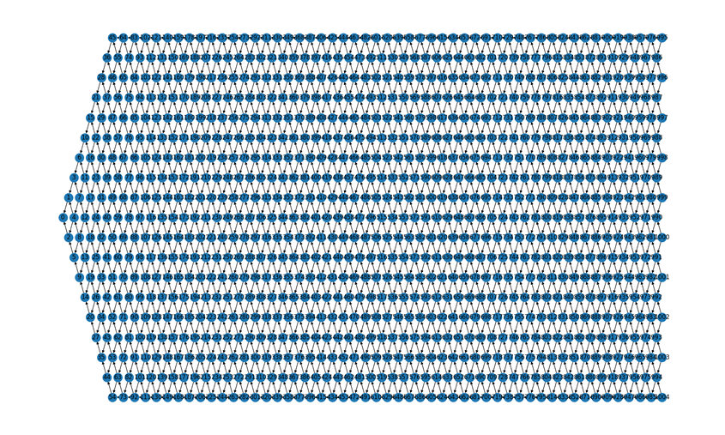

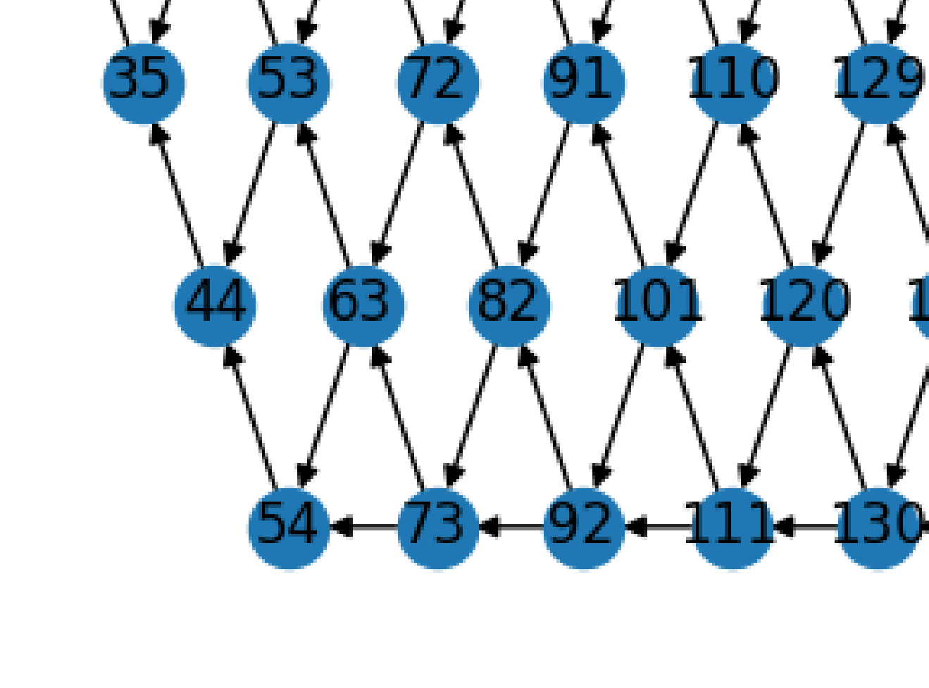

Week 4 (January 31, 2022)

* Determines a name of the topology, to distinguish it from the Tangle
  + Fishing Net Topology(FNT)
* UML Diagram:

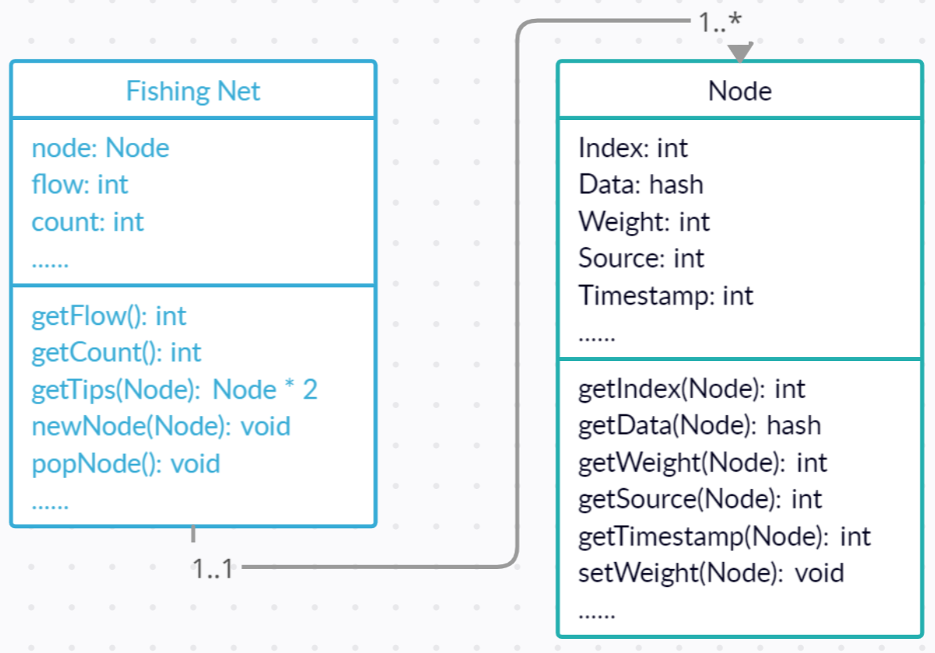

* Github Page:

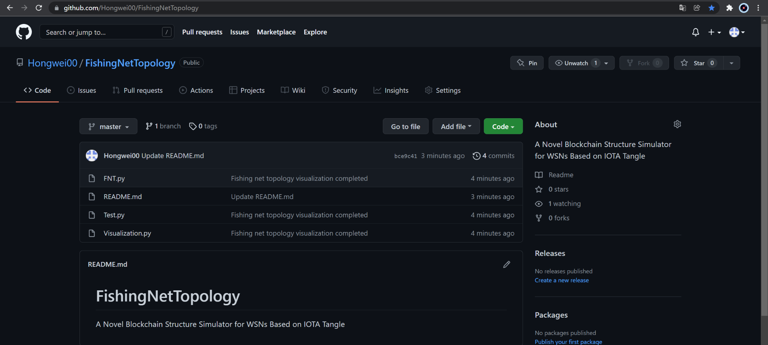

* Cumulative Weight Computation:

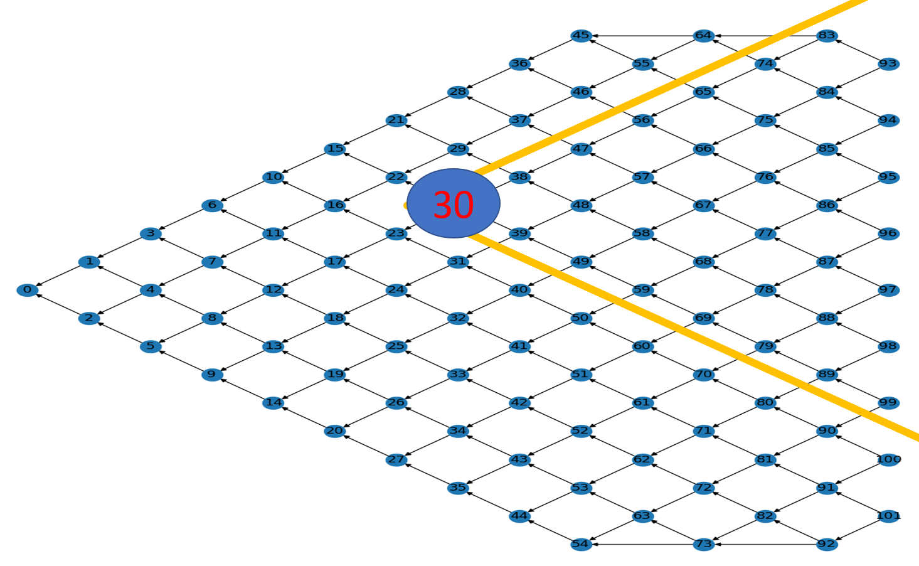

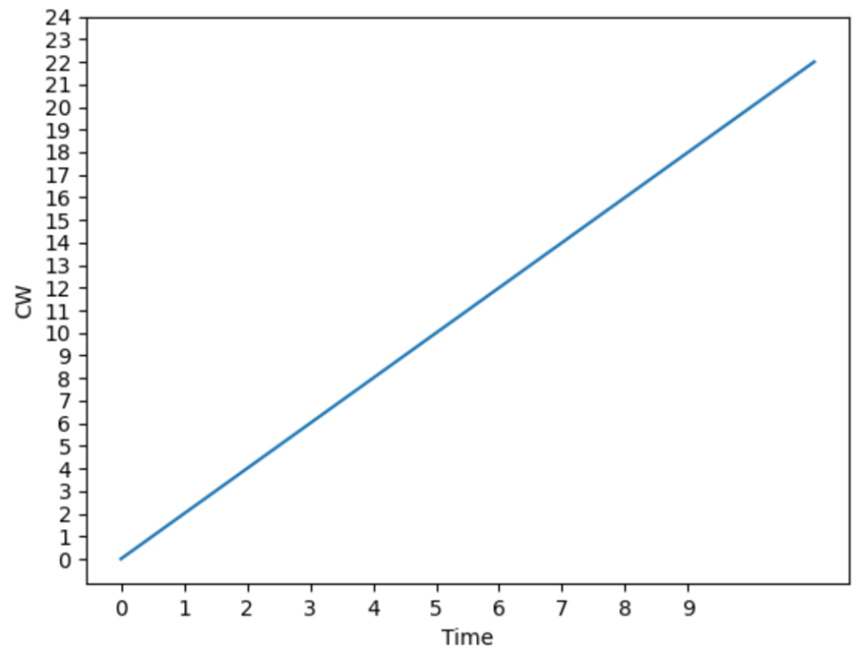

Week 5 (February 7, 2022)

* Structure explanation:

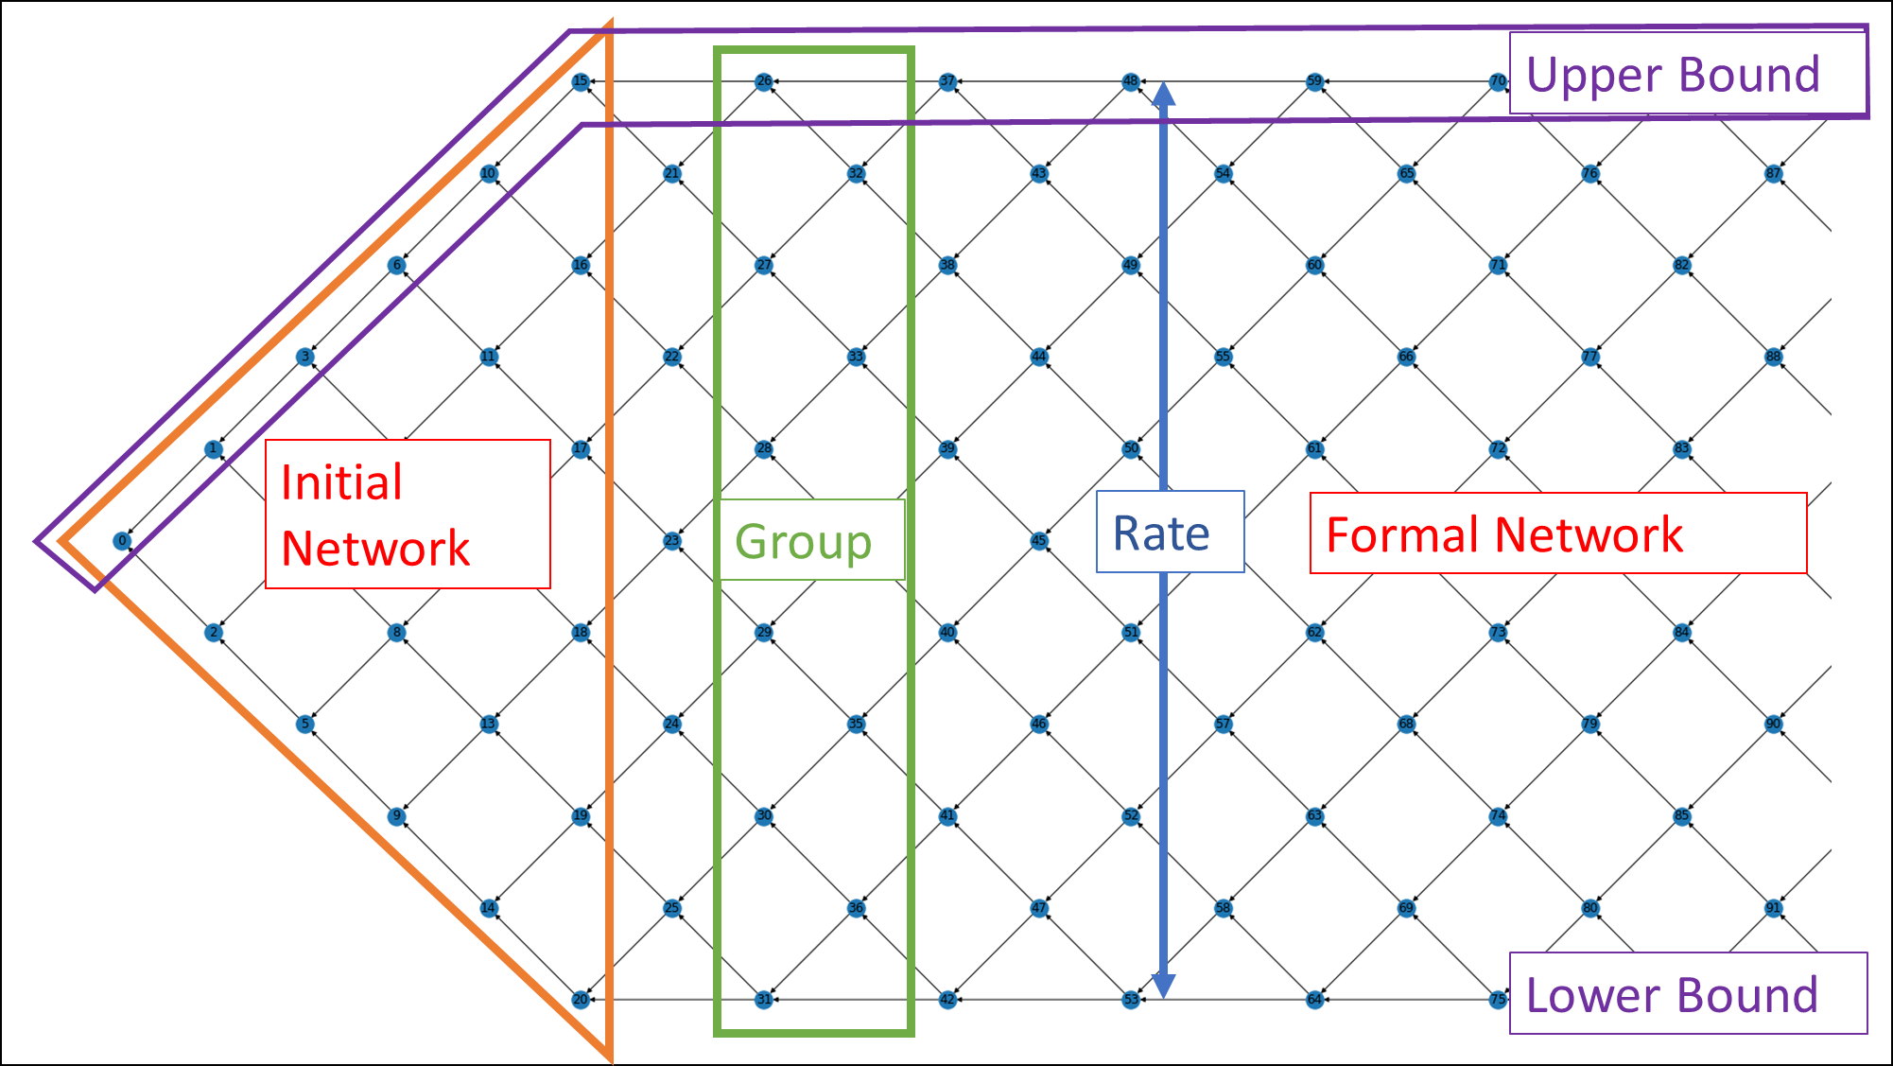

* FNT class complete:

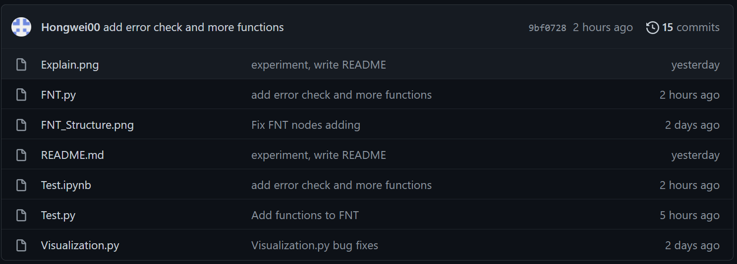

Week 6 (February 14, 2022)

* Initial Network:
  + The part that allows the network to progressively reach maximum throughput.
  + The part used for network initialization, starting from node 0, each column has one more node than the previous one, until the number of nodes reaches the number of the Rate.
  + Form a triangle.
* Formal Network:
  + The formal network is the main part of the FNT.
  + At this point, the network can reach maximum throughput.
  + The number of nodes in the first column is equal to Rate, and the second column is one smaller than Rate, these two columns form a Group.
  + The structure of the formal network is the repetition of the Group.
* Rate:
  + The data packet throughput in the network.
  + The maximum number of packets going through the network at the same time.

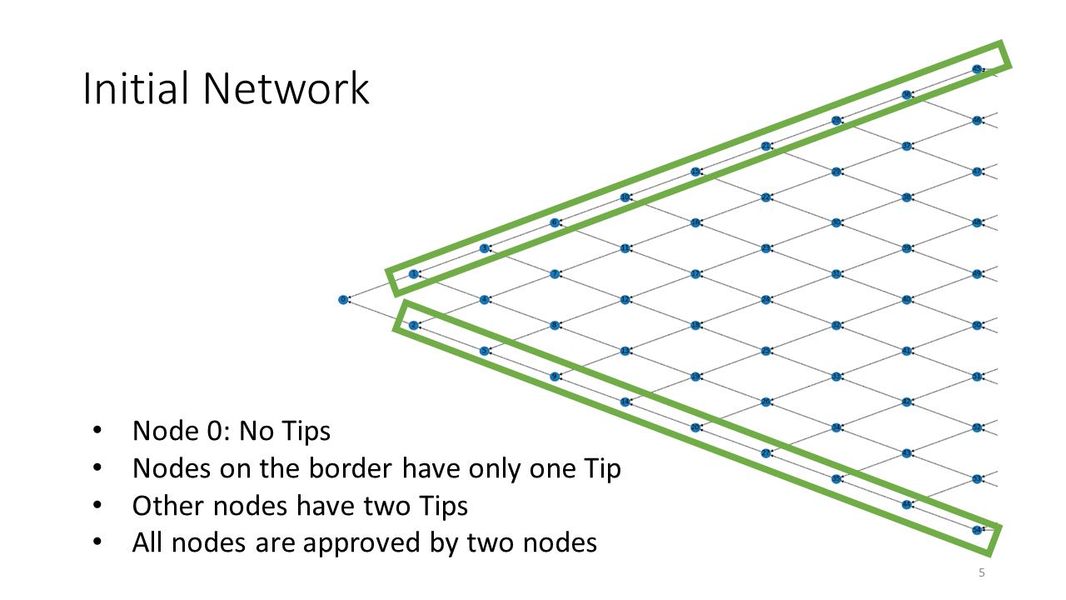

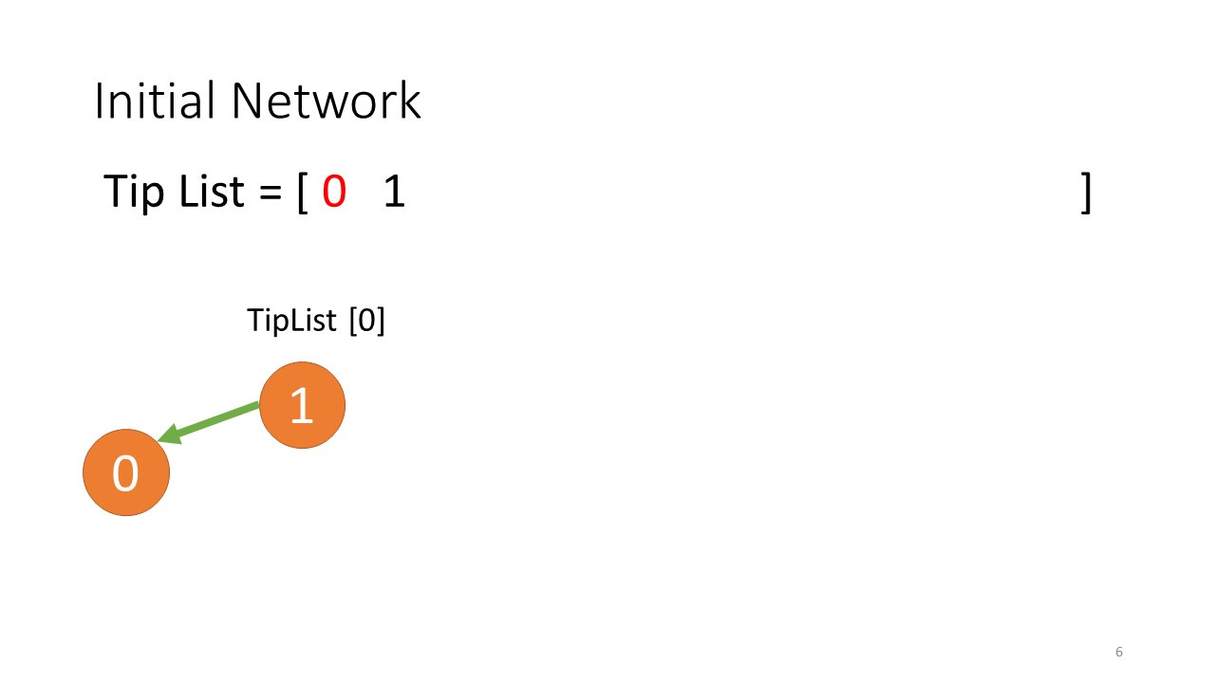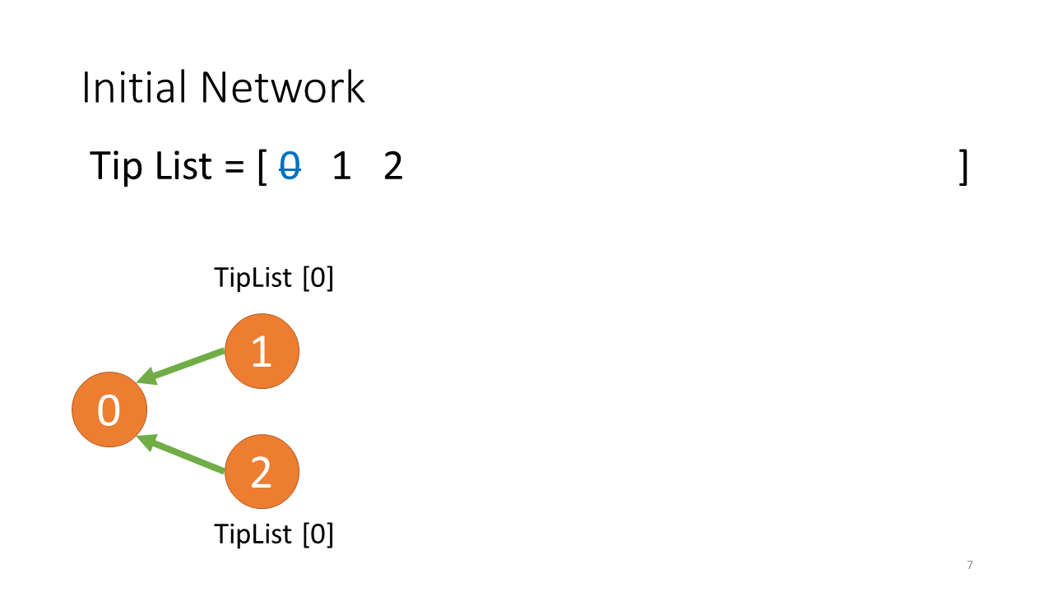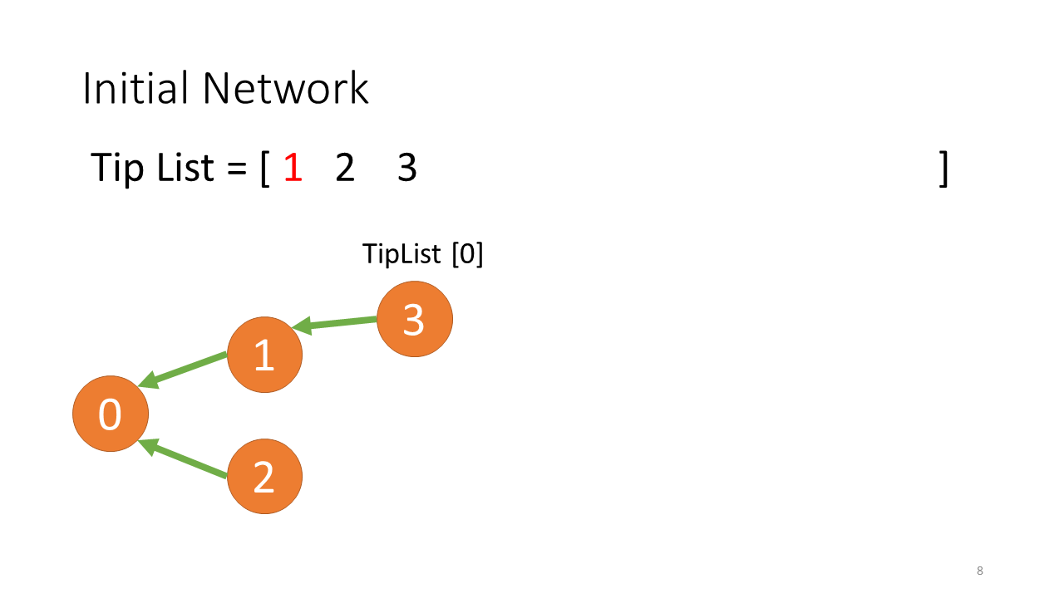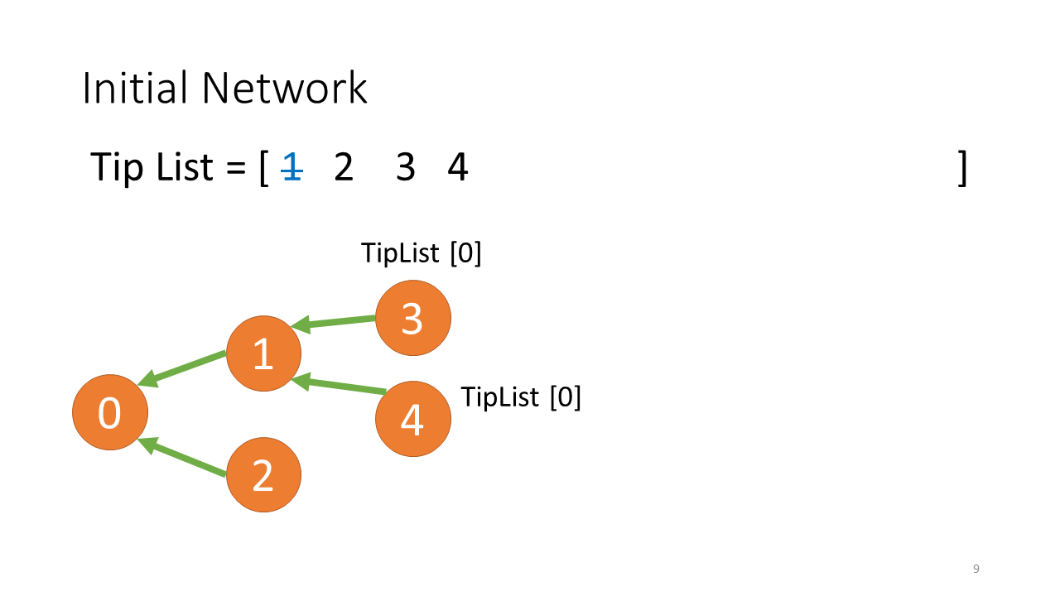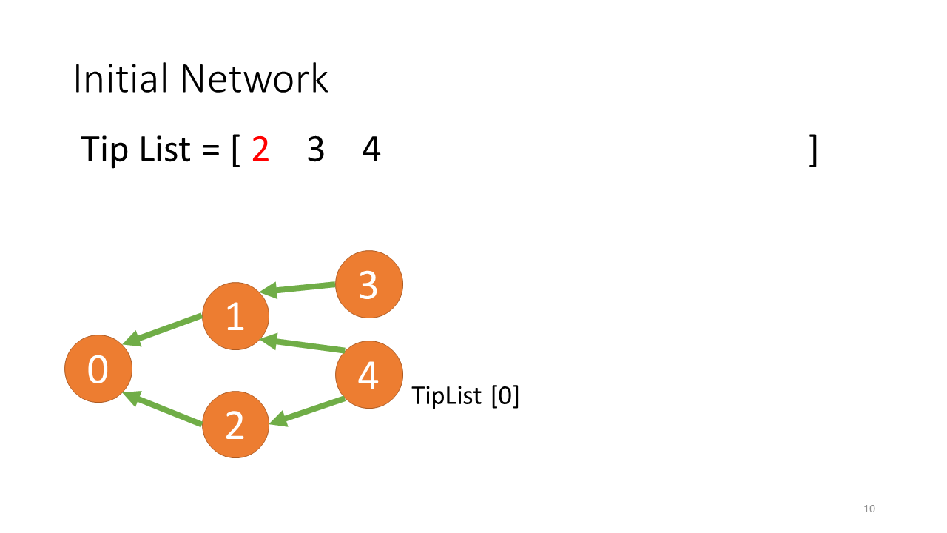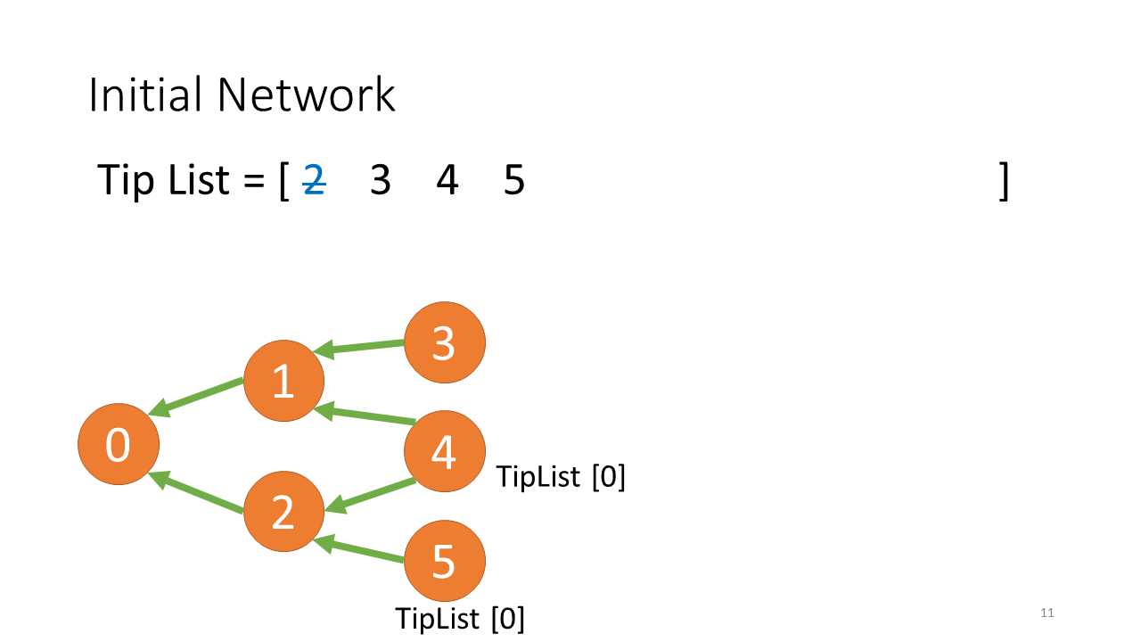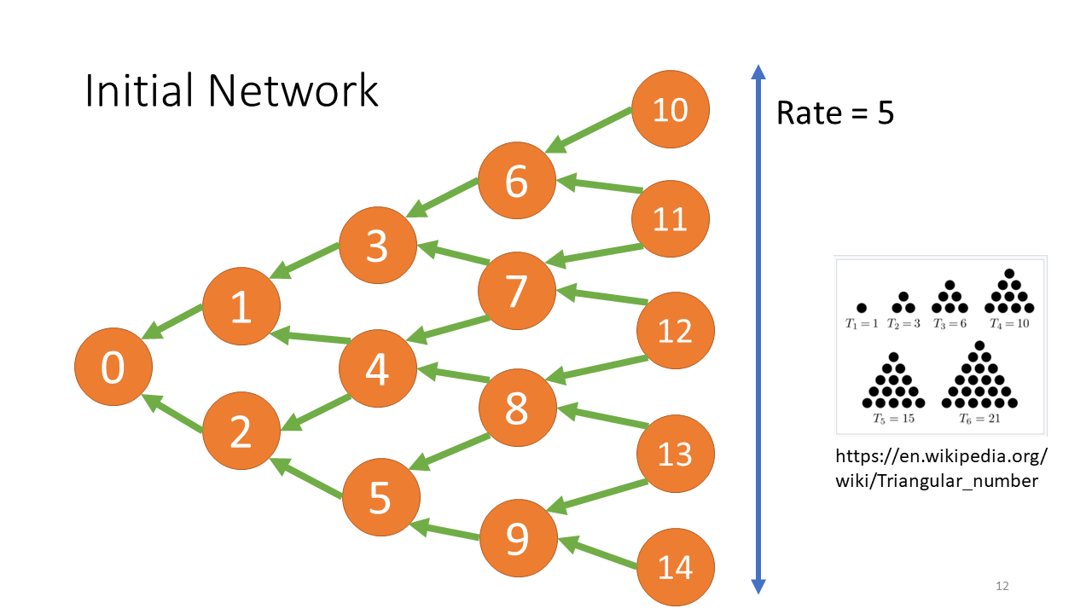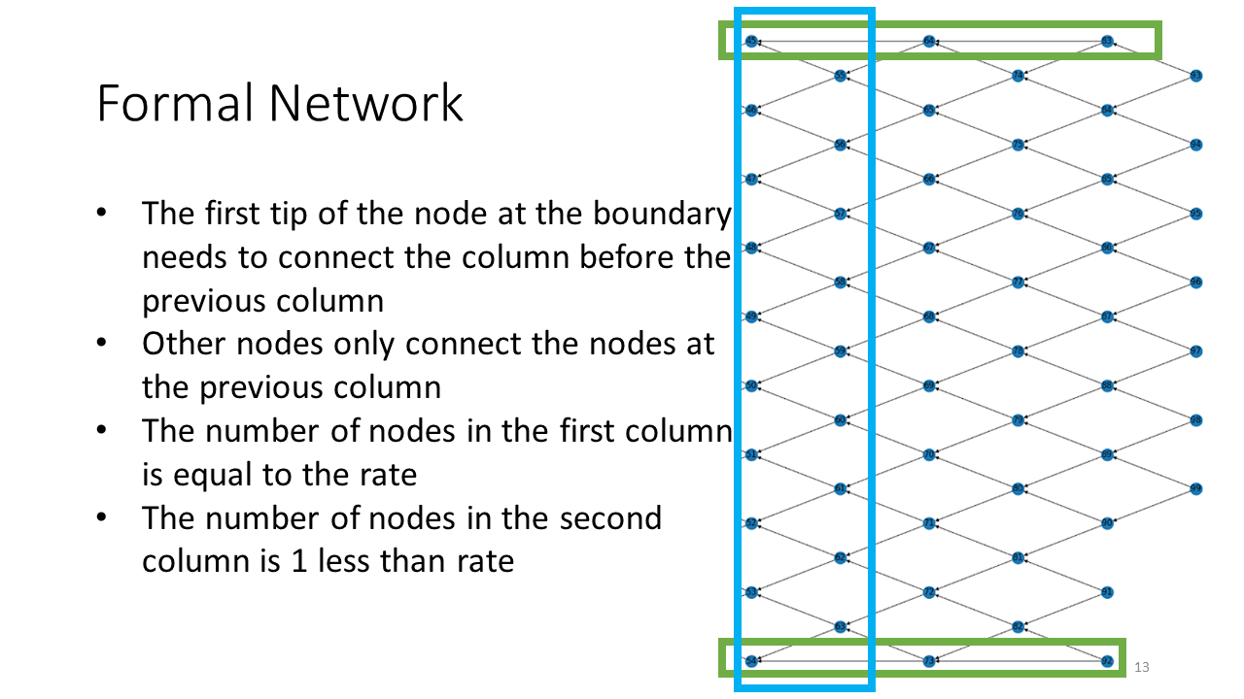

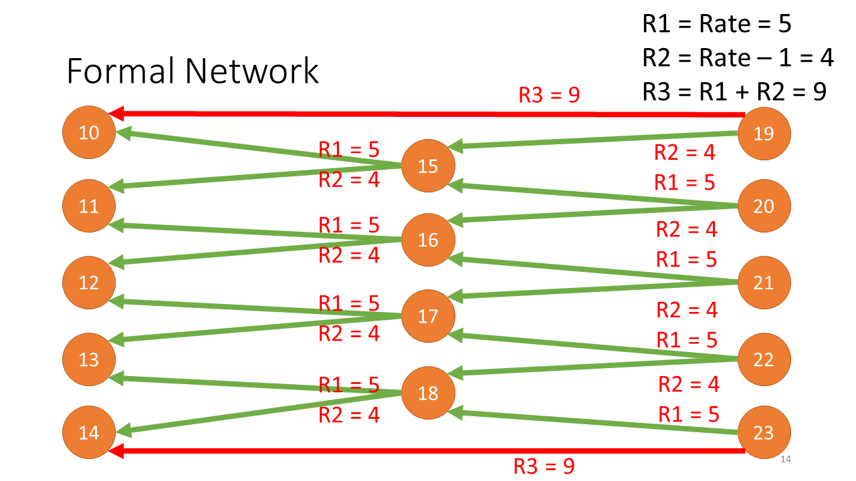

Week 7 (February 21, 2022)

* CW Graph in FNT (Rate of 6, 100 nodes):

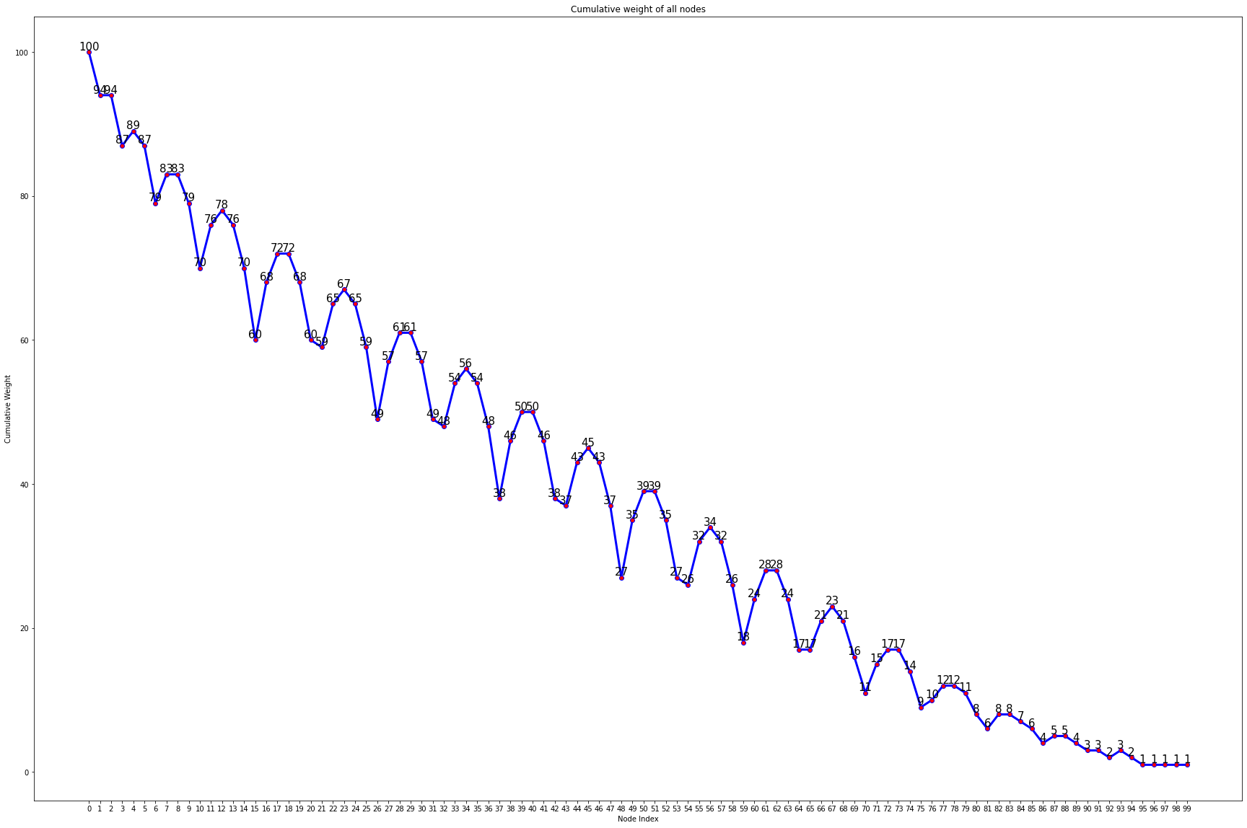

* CW Graph in Tangle (Rate of 6, 100 nodes):

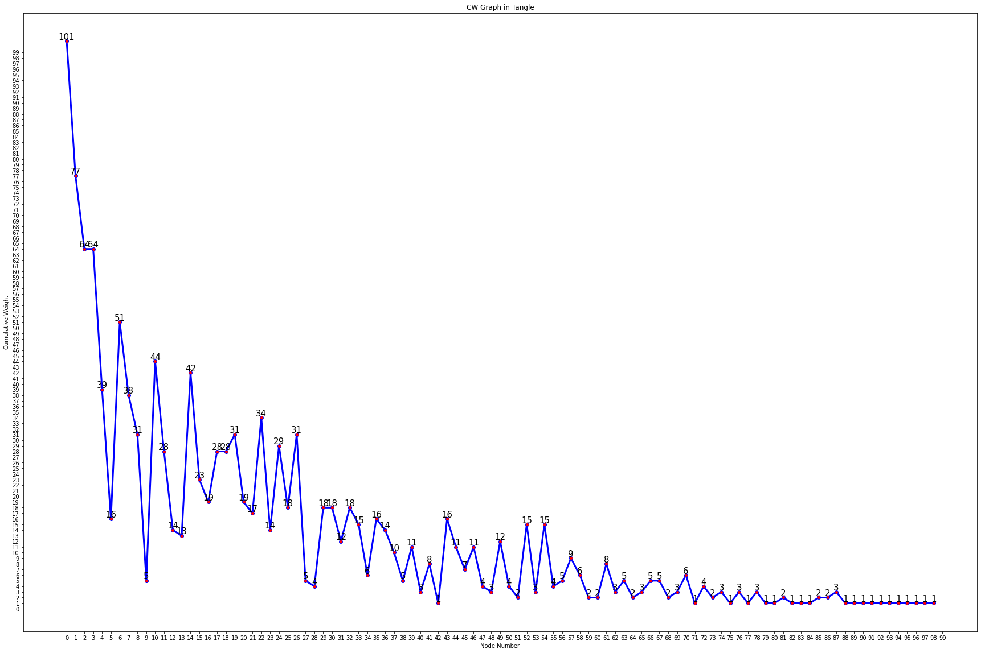

* CW Change of a node in FNT (Rate of 6, 100 nodes, Node 15):

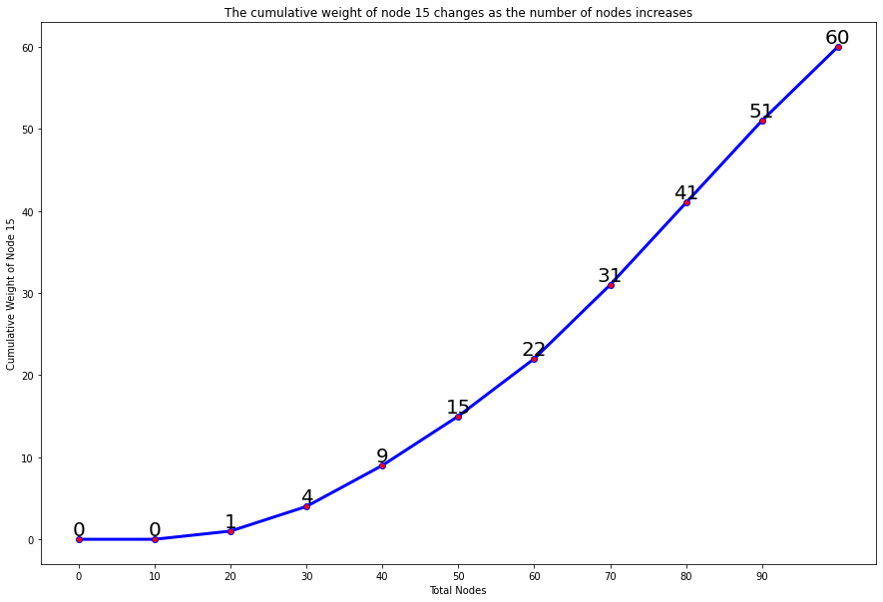

* CW Change of a node in Tangle (Rate of 6, 100 nodes, Node 15):

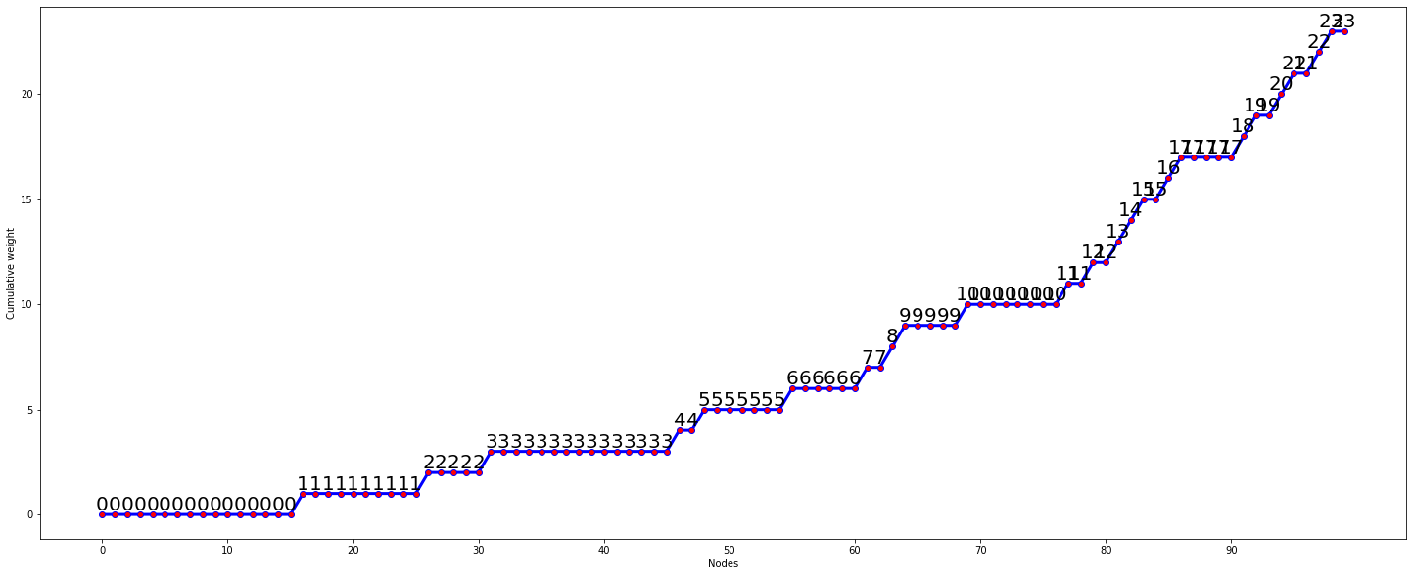

Week 8 (February 28, 2022)

* Growth of CW of a node as number of nodes increases

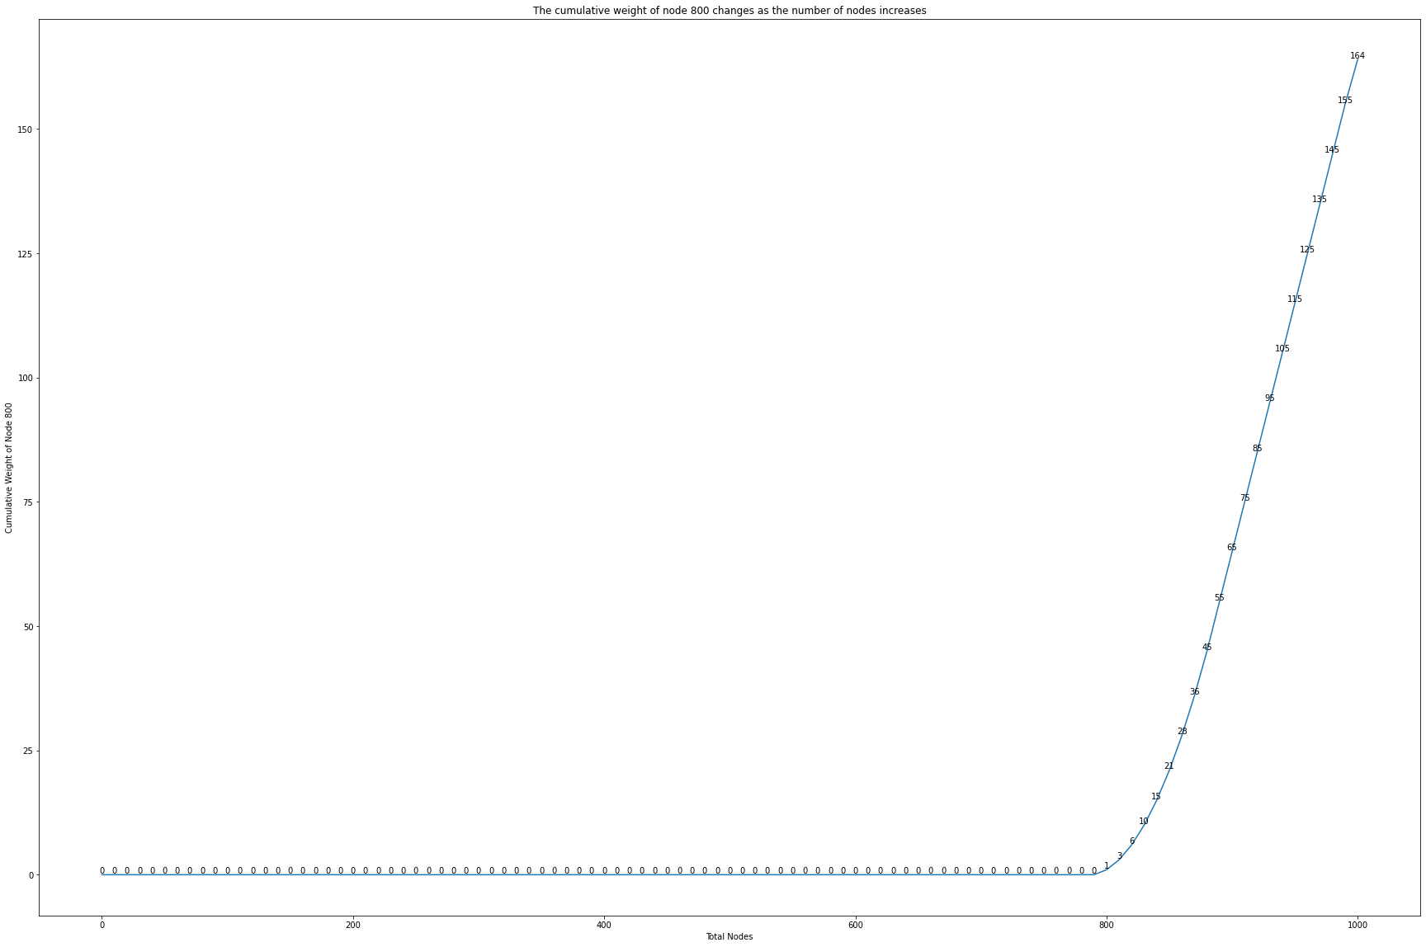

* Throughput of each layer

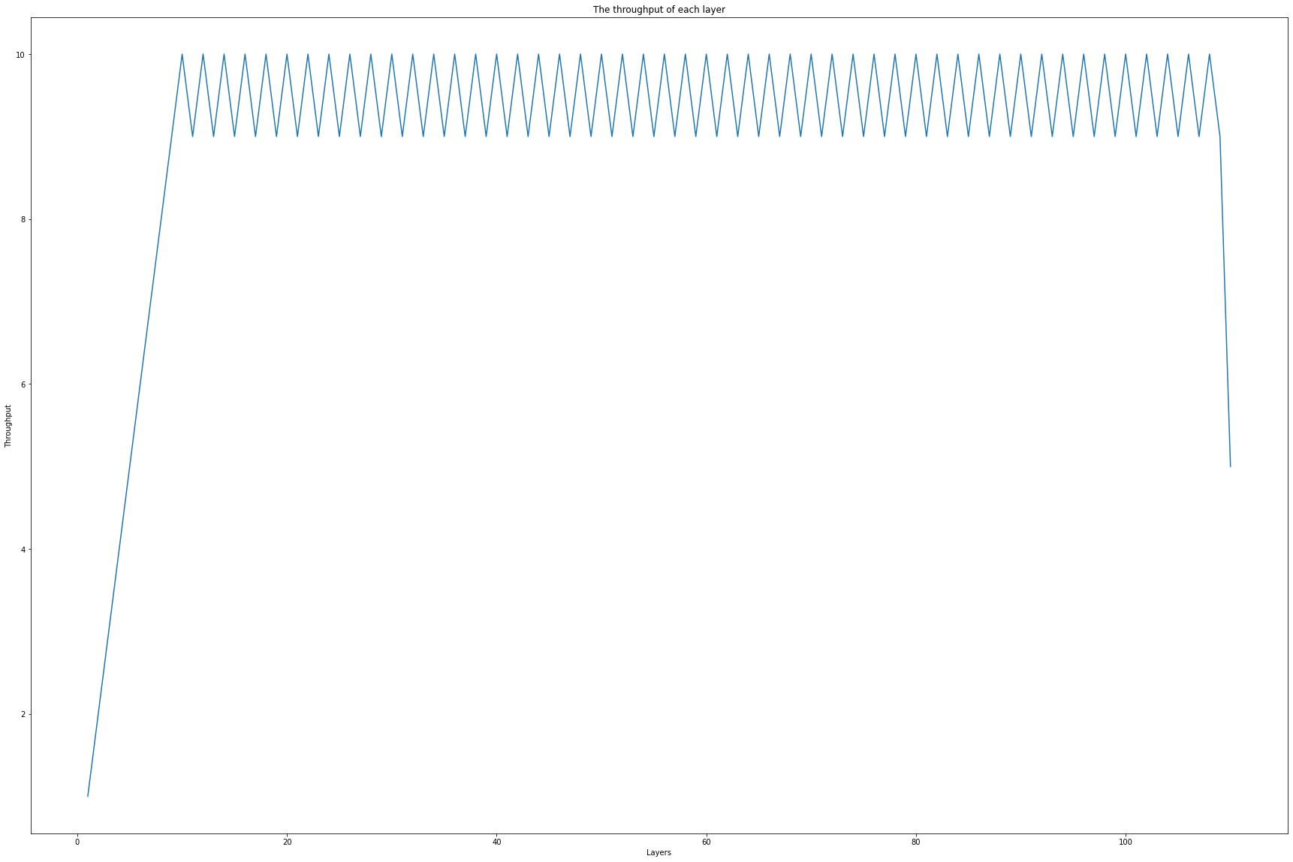

* Utilization of each layer

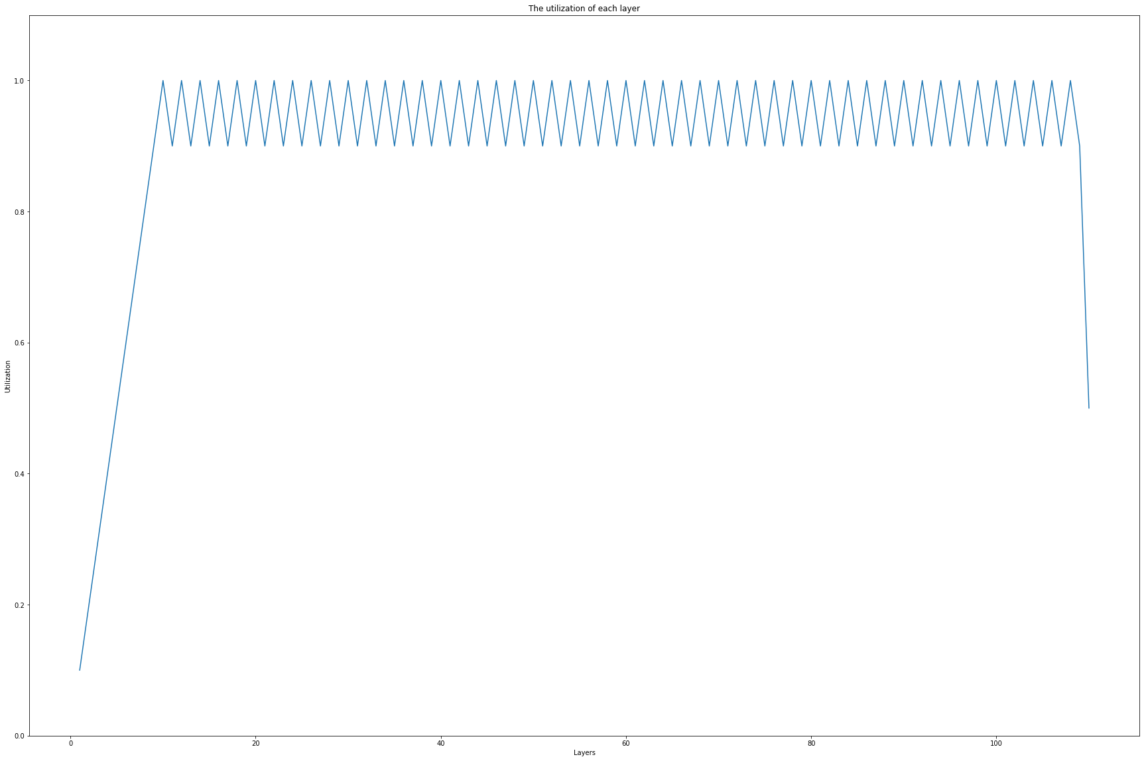

* Waste rate of each layer

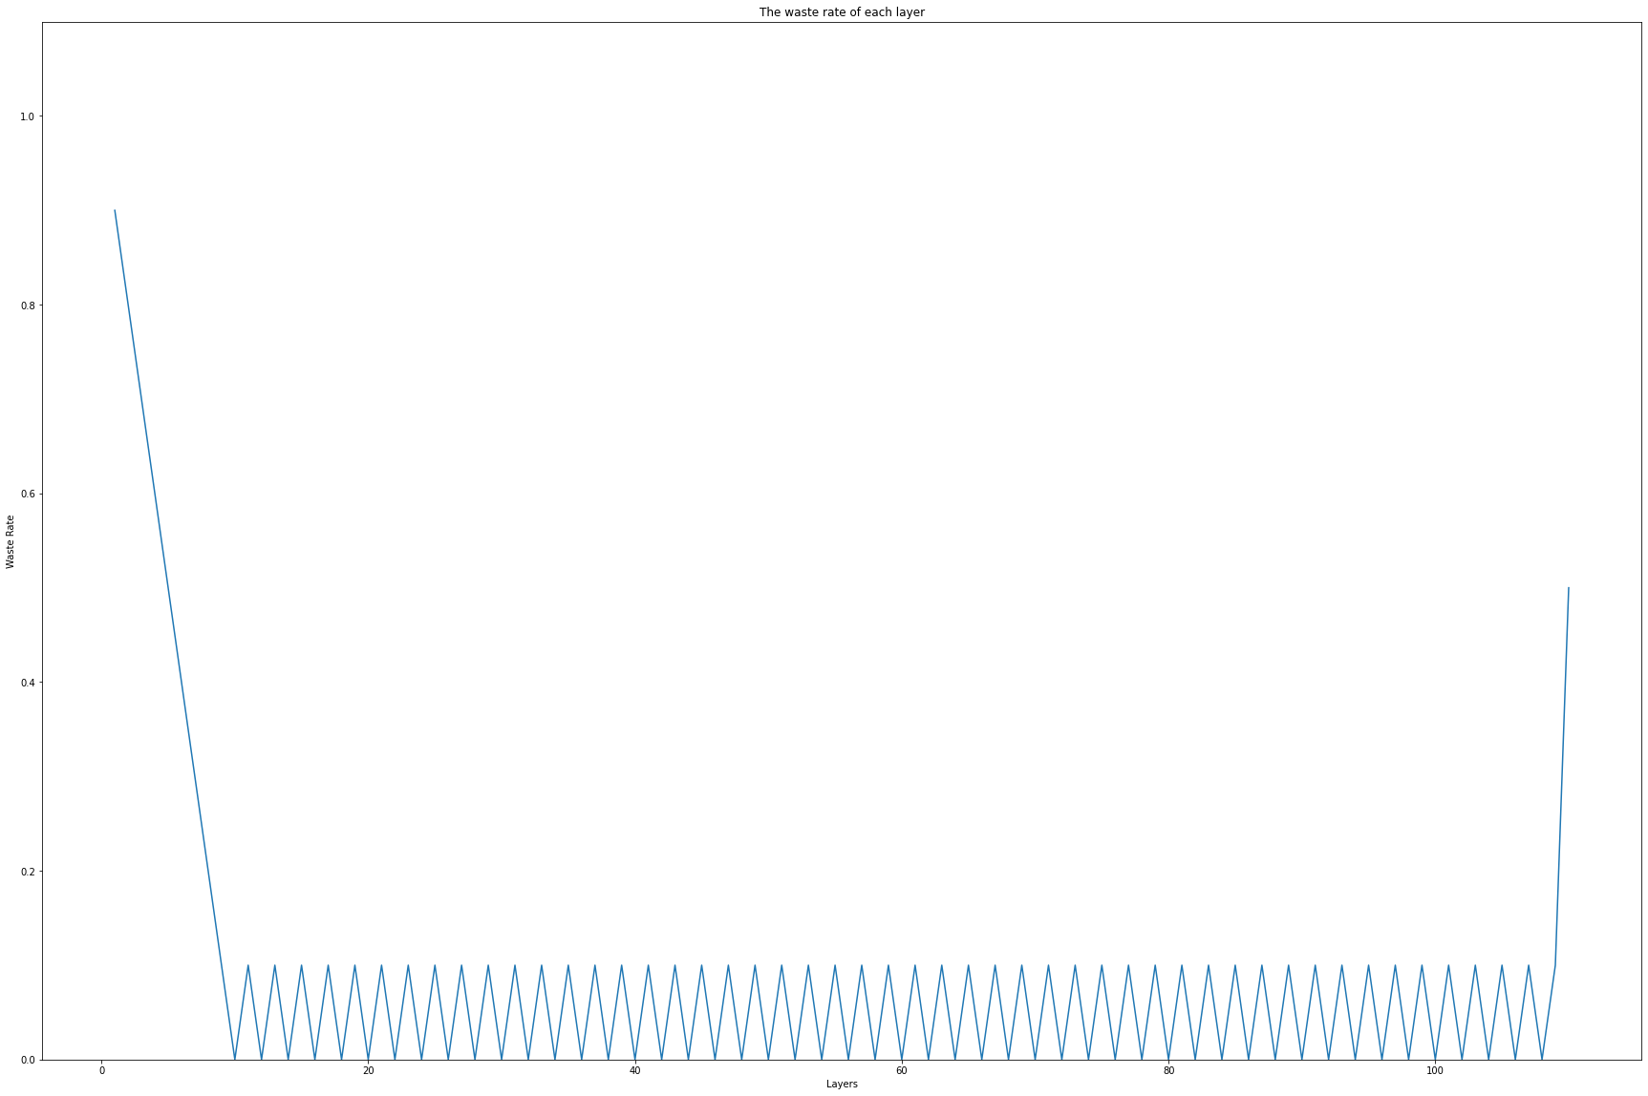

* Cumulative waste rate

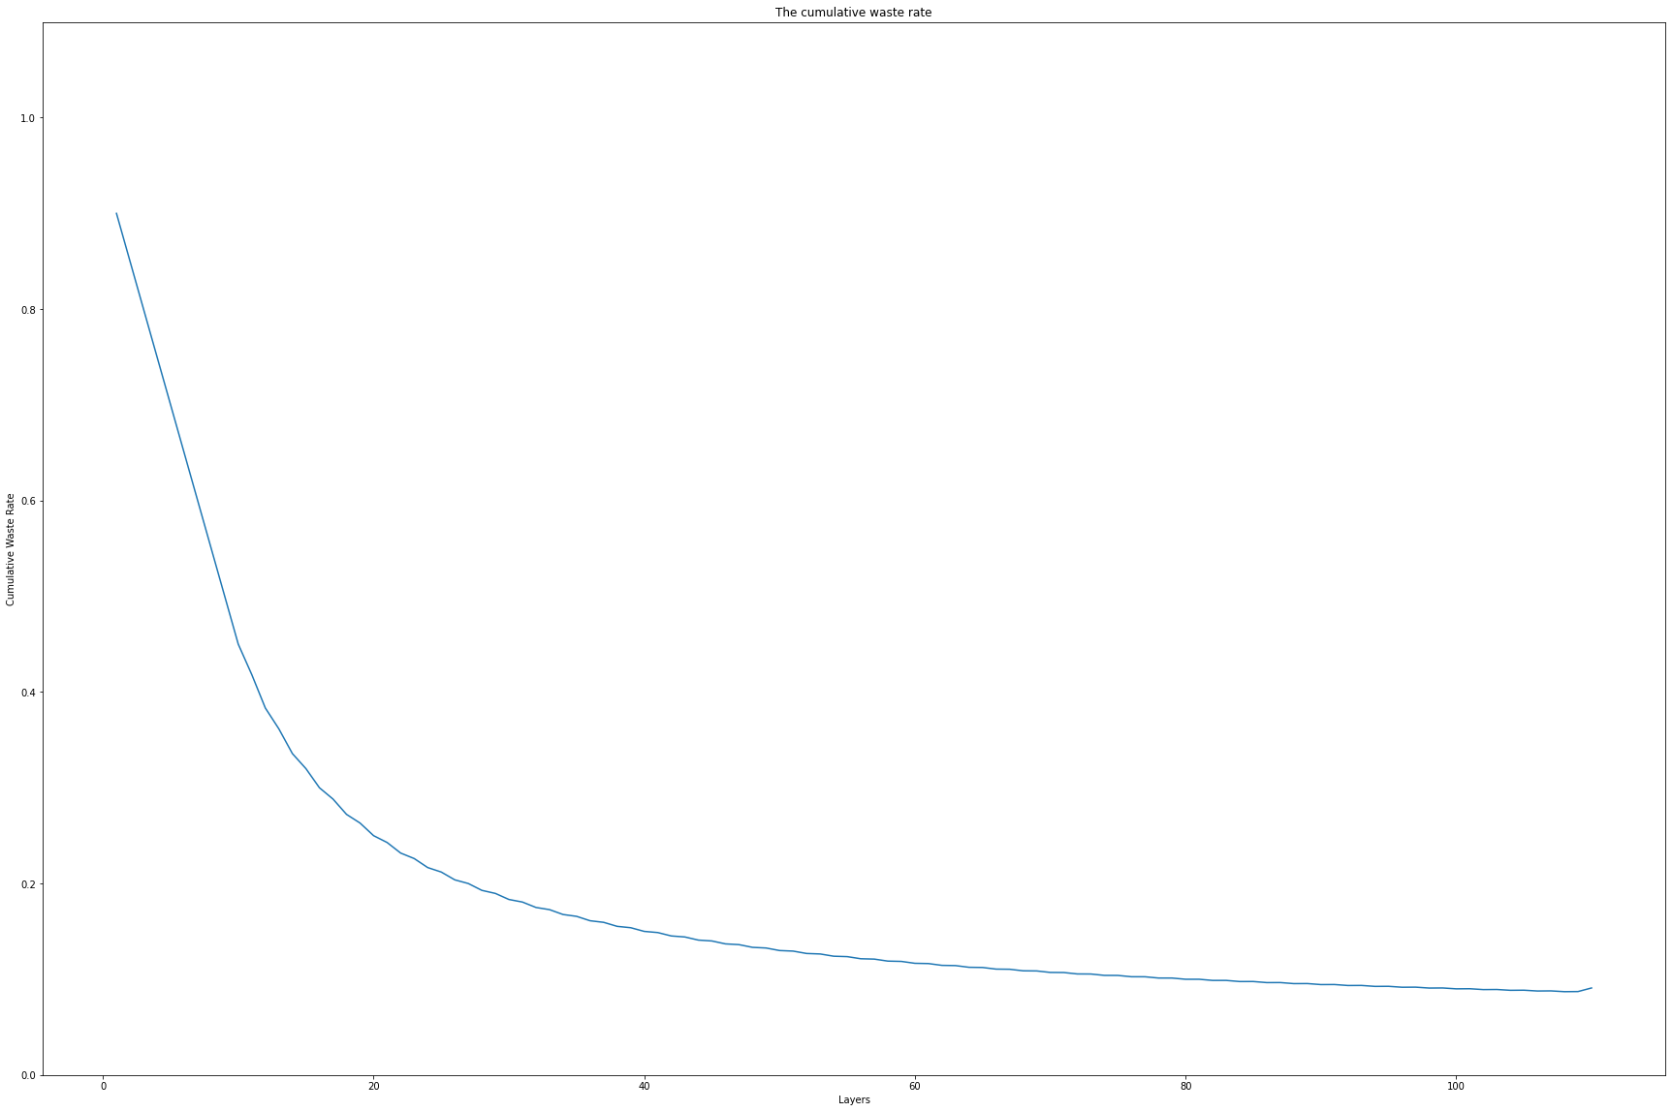

* For the same Rate, in the case of nodes of different orders of magnitude, the throughput waste comparison.
  + Conclusion: In the case of the same rate, the larger the number of nodes, the smaller the waste.

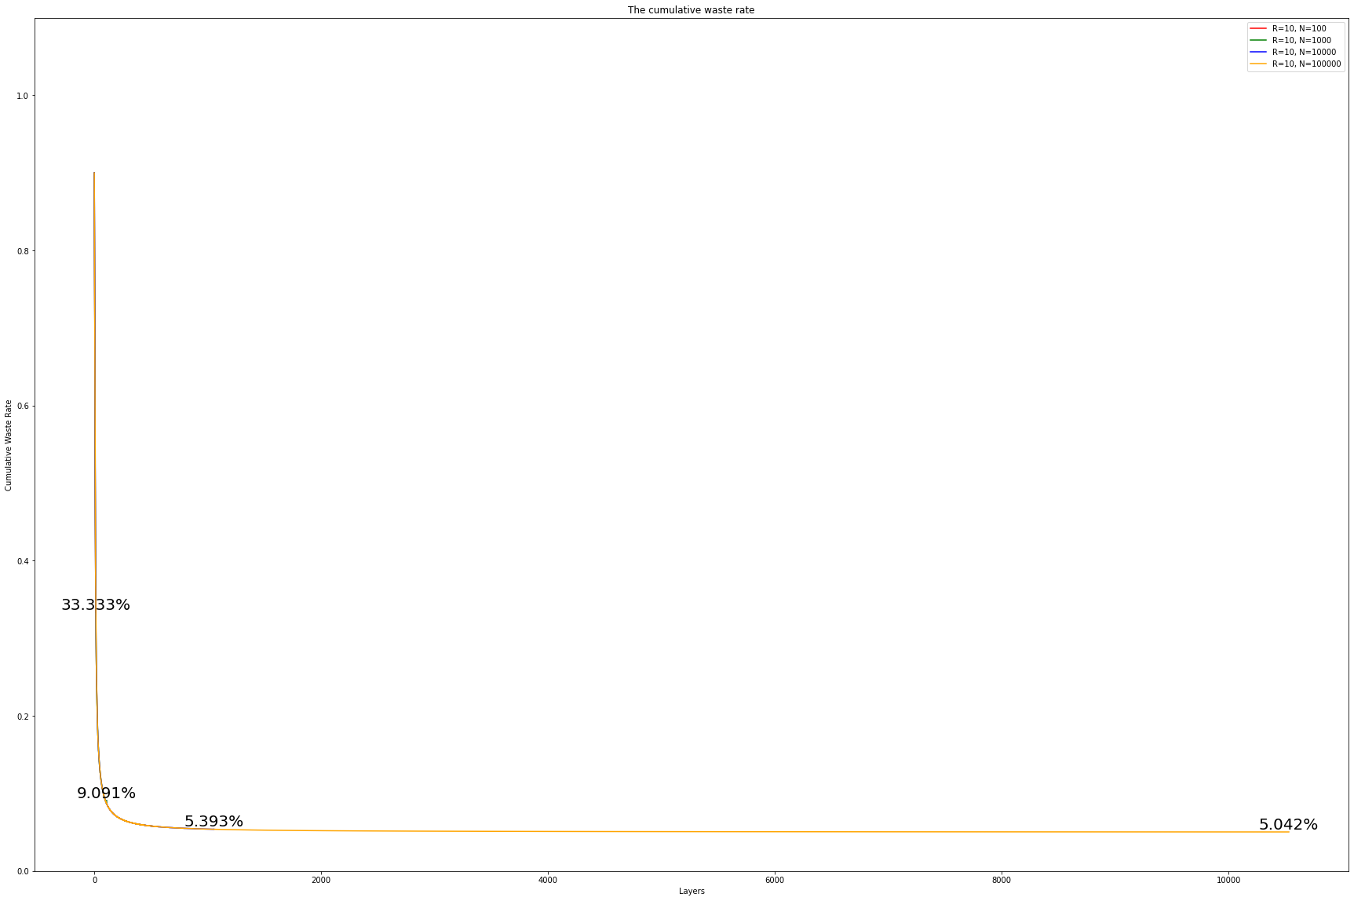

* For the different Rate, in the case of nodes of same orders of magnitude, the throughput waste comparison.
  + Conclusion: For 1000 nodes, among 4 different rate comparisons, rate 10 is the most suitable.
  + Conclusion: For 10000 nodes, among 4 different rate comparisons, rate 15 is the most suitable.

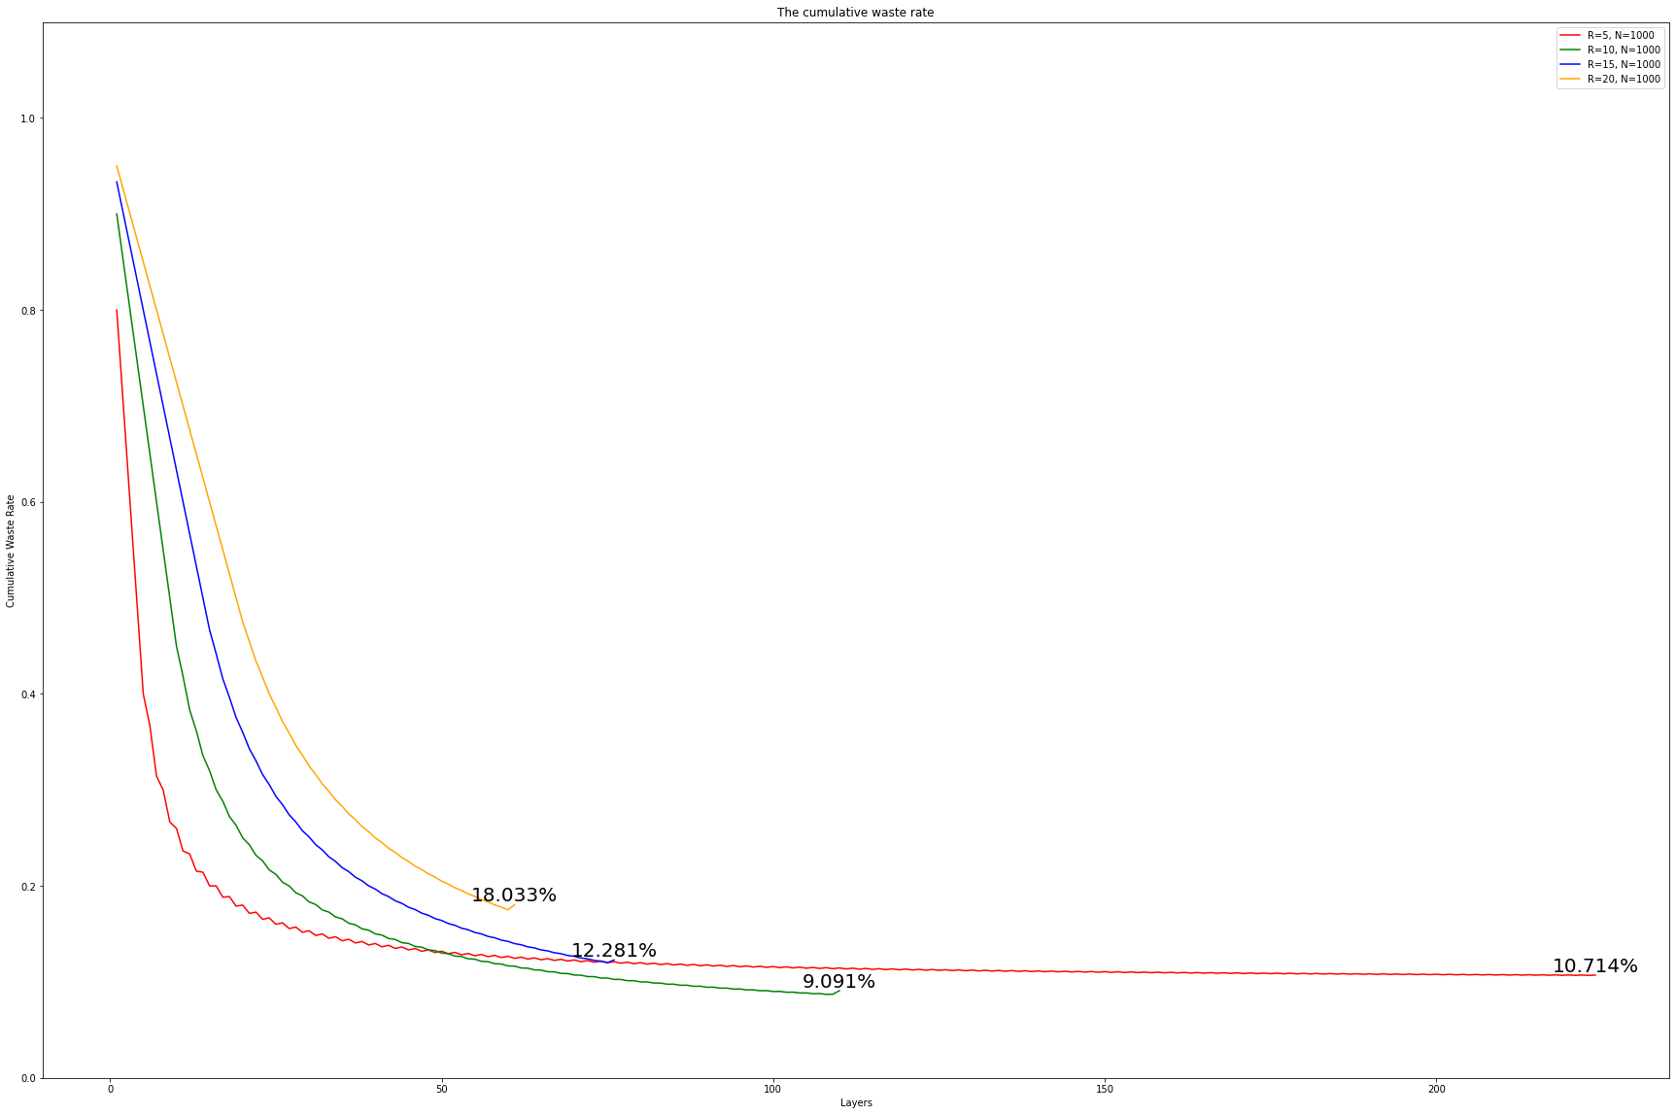

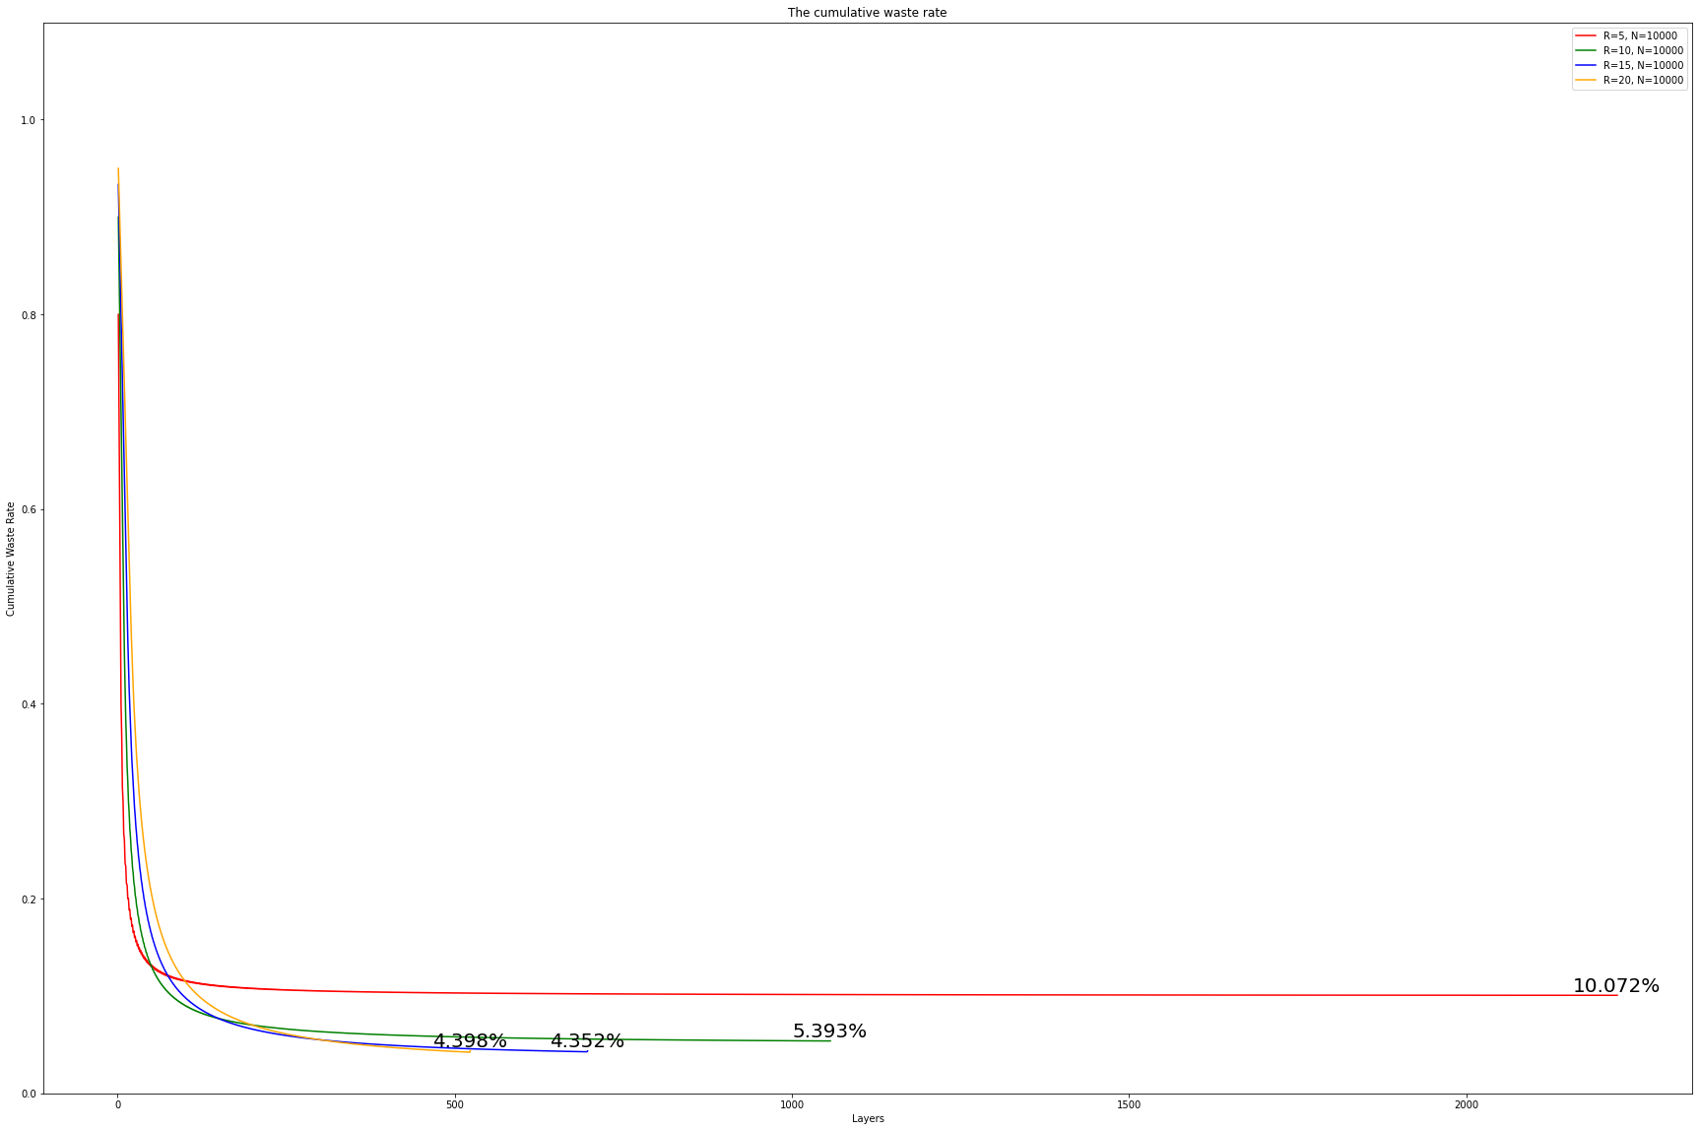

* Overall conclusion: For nodes of different orders of magnitude, there is a rate that is most suitable for it to maximize the utilization of the network (minimize the waste)

Week 9 (March 7, 2022)

* Thesis Outline
  + **Abstract**
  + **Chapter 1: Introduction**
    - Motivation
    - Summary overall
  + **Chapter 2: Background and Literature Survey**
    - A brief introduction to the background of WSN, IoT, Blockchain, IOTA Tangle.
    - Introduce existing Tangle simulation and performance.
  + **Chapter 3: Your proposal/methodology**
    - FNT structure explanation, function introduction, terminology.
    - Similarities and differences with the Tangle.
  + **Chapter 4: Experimental Results**
    - Compare with the Tangle structure.
    - Network utilization, waste rate, tips finding.
    - The performance of nodes of different orders of magnitude at the same rate.
    - The performance of nodes of the same order of magnitude at different rates.
  + **Chapter 5: Conclusions**
    - Summary
    - Limitation
    - Future work
  + **References**

Week 10 (March 15, 2022)

* Honour Thesis first draft submitted.